 | jk"Vªh; izkS|ksfxdh laLFkku jk;iqj  NATIONAL INSTITUTE OF TECHNOLOGY RAIPUR  (An Institute of National Importance)  Under Ministry of Education, Govt. of India  GE Road, Raipur PIN: 492010, Chhattisgarh  Web: www.nitrr.ac.in, Mail: dean_rnc@nitrr.ac.in  Prof. | 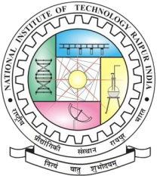
Annexure-1

Academic and Administrative Details of the Conference

- Title of the Conference:
- Objectives of the Conference:
- Proposed dates for the Conference:
- Schedule of the Conference (Tentative):
- Organising Department(s)/Institute(s)/Society (ies):
- Name of the Chairman:
- Names of the Secretaries (Maximum three for the National and four for the International):
- Members of the Organizing Committee:
- Detail of the Reviewers’ Committee:
- Detail of the Advisory Committee (National/ International):
- Expected number of participants (40 nos. for National / 50 nos. for International Conference; out of which at least 50% participation must be from outside NIT Raipur):
- List of Invited / Keynote / Plenary Speakers (Name, Designation and address along with the anticipated schedule of their visit):
- Draft copy of the Conference brochure with registration form:
- Draft copy of the Certificates:
- Details of pre-Conference Workshop / Training Program (if any):

ʃʃʃ

GE Road, Raipur PIN: 492010, Chhattisgarh | Web: www.nitrr.ac.in, Mail: dean_rnc@nitrr.ac.in

